# SOPA and PIPA

On November 16th, 2011, many websites like Tumblr, Mozilla and Techdirt participated in American Censorship Day by protesting against two bills “SOPA", and “PIPA”, which they deemed “draconian”, and claimed that it “violated freedom of speech on the internet”.

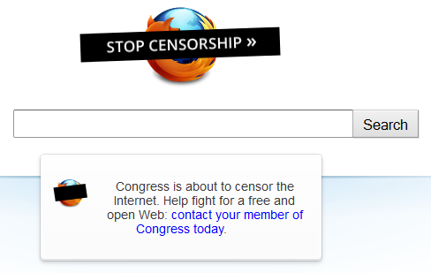

Figure 1: Mozilla's protest against SOPA on November 16th, 2011

A few months later, on January 18th 2012, popular social news site Reddit organized a 12 hour blackout of the site, as its cofounder, Alexis Ohanian, announced that he was going to testify to the US Congress. On the same day, the English Wikipedia replaced all its articles with a page asking visitors to “*Imagine a world without free knowledge”* and displayed a message protesting SOPA and PIPA. This page was reportedly viewed by around 160 million people. The announcement of the blackout was reported worldwide. Newspapers and television channels the world over covered this story, when a majority of the public heard about these bills for the first time. The US version of the Google homepage placed a censor bar above their logo, which on clicking, led to a page about SOPA and PIPA.

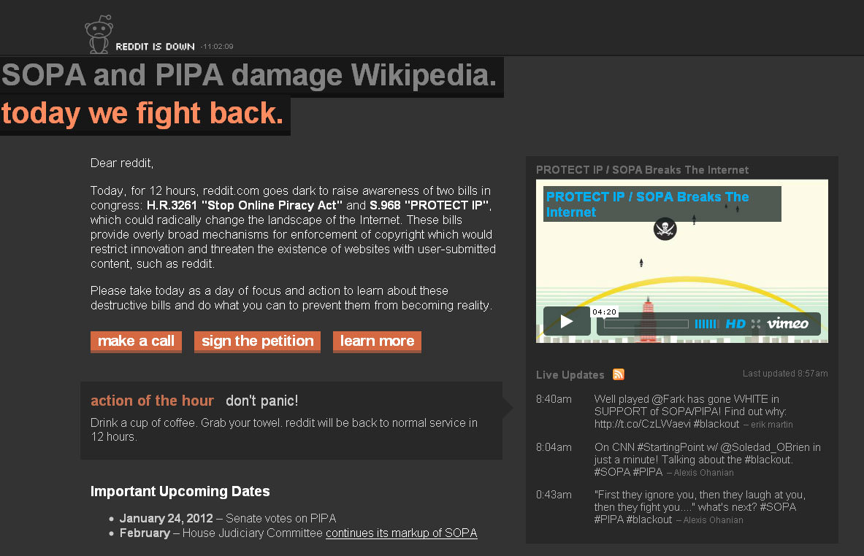

Figure 2: Reddit protests against SOPA and PIPA on January 18th, 2012 by asking users to sign the petition to stop the bills from being passed and to call their representatives telling them that they oppose the bills

These protests became a major internet phenomenon as more than 115,000 sites changed their homepages to protest against the bills.

The purpose of this article is to examine exactly what these bills stated, and to explain their implications, in order to understand exactly why so many people oppose the bills, when they seem to have fairly reasonable intentions.

# Understanding SOPA and PIPA

SOPA stands for “Stop Online Piracy Act”, and PIPA stands for “Protect IP Act”. Both the bills are similar in intent. SOPA is the version of the bill that came from the House of Representatives. PIPA, a very similar bill, was drafted by the Senate. Both were made in order to combat online piracy. While both the bills support a seemingly benign cause, had they been passed, they would have many other ramifications as well. Let us attempt to explain this.

Suppose you(a resident of the United States) are the owner of a piece of music or any other copyrighted work. You find that a foreign website (website whose servers are not in the United States) is infringing upon your copyright, according to US law. Even if you file a lawsuit against that site, there is nothing the government can do to stop that website, because it is a foreign website, and does not fall under US jurisdiction. So the purpose of these bills is to give tools to such actors(the government, you) to stop this. However, as we shall later see, the bills do much more than just stop online piracy. These bills, rather than targeting the offending website itself, target sites *within* the United States (since they *do* fall under US jurisdiction) that in some way benefit the website in question. These include:

* **Search engines**

With these bills in effect, the government can target search engines *within* the United States, like Google, Bing and Yahoo! and ask them to remove all results linking to the website in question.

* **Payment Processors**

Payment Processors such as PayPal may be asked to stop doing business with the offending website.

* **Advertising Networks**

The government may stop Ad Networks from displaying ads on the site in question, which would thus prevent the site from getting any revenue from them.

* **DNS Servers**

These servers associate the domain name of a website with the actual servers. The bill gives the government the power to make the DNS Servers completely cut off ties with the website. In other words, if the website in question is facebook.com, typing facebook.com in your address bar would no longer link to Facebook.

So, all of the above are things *within* the United States that, to some degree, this site is dependent on. Thus, SOPA and PIPA give powers to the government to issue court orders and notices to compel the above intermediary actors to cut off all ties with the infringing website. If they fail to comply, *they* are liable to face legal action.

One might think that this is all very well. After all, this is what the bill is supposed to do. However, these bills may affect perfectly innocent sites as well.

To understand this, we shall quote Section 103 of the Stop Online Piracy Act.

(a) Definitions- In this section:

(1) DEDICATED TO THEFT OF U.S. PROPERTY- An `Internet site is dedicated to theft of U.S. property' if--

(A) it is an Internet site, or a portion thereof, that is a U.S.-directed site and is used by users within the United States; and

(B) either--

(i) the U.S.-directed site is primarily designed or operated for the purpose of, has only limited purpose or use other than, or is marketed by its operator or another acting in concert with that operator for use in, offering goods or services in a manner that engages in, enables, or facilitates--

(I) a violation of section 501 of title 17, United States Code;

(II) a violation of section 1201 of title 17, United States Code; or

(III) the sale, distribution, or promotion of goods, services, or materials bearing a counterfeit mark, as that term is defined in section 34(d) of the Lanham Act or section 2320 of title 18, United States Code;

Firstly, let us examine 1.B(i). According to the bill, a site is deemed to be “dedicated to theft of U.S. property” if it “enables, or facilitates” the above-mentioned violations. What does that mean? Suppose now, that you run a blog. People are allowed to comment on your blog. Someone posts a link to a video, or picture, which is protected by copyright, and which you do not have the rights to. Then, under this definition, technically, your site is “enabling”, or “facilitating” this copyright violation. So, the bill gives the government the power to issue court orders to DNS Servers, Payment Processors, etc to cut all ties with your website! Also, this is a very “shoot-first-then-think” sort of approach. Normally, if a site is suspected to be dedicated to copyright infringement, the site is initially given a notice to remove the infringing content within a certain period of time. If it is not removed by then, only then would the government attempt to block the site. However, with these bills, the US government can, *without warning,* cut access to your website by the above mentioned methods. Even if they were wrong about their claims, and you were not really infringing on anyone’s copyright, or you had already acquired the rights to use the material, your site would have already lost a lot of revenue by then, because people (from the US) would not be able to access your site until it is back up, and you would no longer get revenue from ads for that period of time. The same is true for perfectly legal sites with user-generated content, such as YouTube, Vimeo, Facebook, etc. To top it all, for small businesses, suing back is a very expensive affair, and even more so when the site in question isn’t generating any revenue for that period of time.

You might think that there must be a way to legally sue them back for the damages incurred in such a case. There indeed is.

We again quote the Stop Online Piracy Act:

(6) MISREPRESENTATIONS- Any provider of a notification or counter notification who knowingly materially misrepresents under this section--

(A) that a site is an Internet site dedicated to the theft of U.S. property, or

(B) that such site does not meet the criteria of an Internet site dedicated to the theft of U.S. property,

shall be liable for damages, including costs and attorneys' fees, incurred by the person injured by such misrepresentation as a result of the misrepresentation.

Here, the phrase “knowingly materially misrepresents” is very significant. In almost all cases, the government *wouldn’t* have *knowingly* misrepresented your site’s intentions. In other words, even if you sue the company which misrepresented the intentions of your site, they could always claim that they did not *knowingly* do so, and get away with it.

# Implications

If these bills are passed, a lot that we take for granted about the internet, would change. For example, let us consider Facebook. Facebook completely comprises of user-generated content. If anyone makes an infringing post, the entire website is liable to be blocked. It is now Facebook’s responsibility to ensure that such material does not enter the website. So, in order to prevent this from happening, Facebook would have to physically monitor each and every post made on the website. People would have to think twice before they post a video of the song they wanted to share with their friends. The internet is no longer free and open; communication would be monitored closely. The same would be true for every other site on the internet which includes user-generated content, including YouTube, Reddit, Tumblr, etc.

# Effectiveness

It should be clear by now that these bills cause more harm than any good. In fact, many people have argued, that the bills wouldn’t actually do much to actually combat piracy. Even if a website dedicated to copyright infringement were to be blocked, it could just reappear under a different name within hours. Also, they could also make their IP addresses public. So, a person looking for the website could simply type in the address directly to access it.

# Alternatives

A viable alternative to SOPA and PIPA could be the OPEN Act. In short, the OPEN Act would be way more effective in combating piracy, while not affecting freedom of speech on the Internet.

Thus, these bills simply wreak too much havoc, while not achieving much. There are way smarter, and more effective ways to fight the cause of combating online piracy without effectively censoring the entire internet. Due to the huge protest against these bills, they have now been shelved, but they could well have been passed. It is important to not remain ignorant and not let such laws be passed under our very nose. This may have been a US law, but it would have affected us directly, even in India. It was because of the campaigns undertaken by many companies like Google, Mozilla and the Wikimedia Foundation, that people became aware of the existence of these bills and signed petitions to stop it from being passed. Those of you living in India, who did sign, did make a difference. The internet does not belong to any one country, and we are all equally a part of it. We, as netizens, should stand up for the democracy the internet has become and should definitely not let anyone take *that* away from us.

Arun Mahadevan